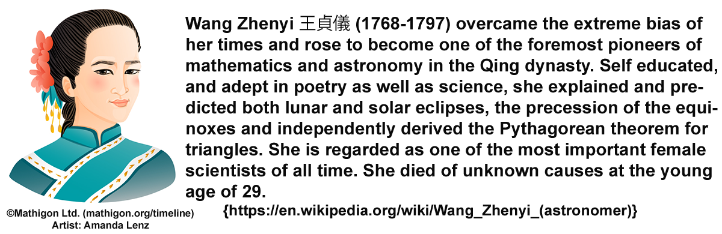
Shenggang Liu Education Foundation Zhenyi Wang award for Excellence in IRMMW-THz
About the Award
In 2021, at the behest of Professor Shenggang Liu, the IRMMW-THz Society Board is introducing the “Shenggang Liu Education Foundation Zhenyi Wang award for excellence in IRMMW-THz” to recognize outstanding female contributors to Infrared, Millimeter, and Terahertz wave science, technology and applications. The Award consists of a cash prize of 15,000 RMB (approximately USD2300) and a certificate of recognition stating the research achievements of the award recipient.
A committee of worldwide technical experts in IRMMW-THz science and applications has been assembled and will evaluate nominations received for the award by this year’s deadline: July 30, 2021. The committee will select and announce the winner of the 2021 award at the IRMMW-THz Conference, in Chengdu this September. The Award recipient will be invited to deliver a keynote presentation at the 2022 IRMMW-THz Conference in Rotterdam.
Eligibility Requirements for Applicants:
Application for the 2021 Award is open to women scientists and engineers with a PhD or equivalent degree in Physics, Electrical and Electronic Engineering, Chemistry, Biology or any other relevant IRMMW-THz inclusive research field, of any nationality, from academia, industry, private, or national laboratories. Applicants must have finished their PhD within the last twelve years (plus one more year for each child) on the closing date of the application of the award. Applicants should have an outstanding publication record and must be in a position of independently directing a research group or program (e.g. beyond a post-doctoral position).
Members of the Awards Committee, the Local, or the International Organizing Committee of the IRMMW-THz Society are ineligible for the award.

Applications:
The application package to be submitted by the candidate or nominating sponsor should include:
1. An official application form (download HERE).
2. Two endorsement letters by senior scientists, excluding the candidate's former research advisors.
3. A short curriculum vitae of the candidate (maximum 2 pages).
4. A list of relevant publications.
5. Copies of, or links to the 3 most relevant papers published, or accepted for publication.
The applicant's entire publication record will be considered; however, strong emphasis will be placed on publications that originate after the applicant has moved to an independent research position. The deadline for submitting applications is July 30th. The closing date will be strictly observed.
For questions or additional information contact: Professor Martina Havenith (wangzhenyi@irmmw-thz.org)

