First A. Author1, Second B. Author2, Jr., and Third C. Author3 *11pt*  
1California Institute of Technology, Pasadena, CA, 91125 USA *10pt*  
2Northwestern University, Evanston, IL, 60208 USA *10pt*  
3Huntington Medical Research Institutes, Pasadena, CA, 91105 USA *10pt*

Paper Title for IRMMW-THz 2025 *16pt Times New Roman* 2 PAGE MAX

*Abstract*—A short summary (maximum of 300 words) of the work can go here. Use *9pt bold Times New Roman*. A short summary of the work can go here. A short summary of the work can go here. A short summary of the work can go here. A short summary of the work can go here. A short summary of the work can go here.

# INTRODUCTION *10pt small caps*

T

HIS template should be used for abstract submissions to the *39th International Conference on Infrared, Millimeter, and Terahertz Waves (IRMMW-THz 2014)* to be held from September 14-19th, 2014, at the Student Union of the University of Arizona, Tucson, AZ, USA. Please refer to the conference website for details, including registration and paper submission information: <http://www.irmmw-thz.org/conference/>

The Abstract submission document is a template derived from a standard IEEE style template for paper transactions (<http://www.ieee.org/web/publications/authors/transjnl/index.html>).

The template is for Microsoft *Word* versions 6.0 or later. Note the page size is 8.5x11” (US Letter). Please use *10pt Times New Roman* throughout the main body text. Leave no blank lines between paragraphs, but indent 2 columns (0.14”). Use *single line spacing* under paragraph Indents and Spacing. For the initial header use 12pt above, and 4pt below as shown. For future headers use 6pt above and 4pt below as indicated in section II.

**The length limit for regular FINAL PAPER submissions is two pages including text, figures and references.** Invited papers and Keynote papers may be three pages. Plenary speakers may submit up to four pages. All compliant full papers will be included in the conference proceedings, archived on IEEEXplore, and will be distributed to all conference participants.

Papers must be submitted in pdf format, and they must be compliant with IEEE PDF standards. In order to create an IEEE-compliant pdf file, authors should use the IEEE PDF eXpress web site to convert files to pdf format. Instructions on using this service are available at the ‘Abstract submission’ tab on the conference web site: <http://www.irmmw-thz.org/conference/>

**Please, do not number your pages** and do not use any HEADERS or FOOTERS. This section is the Introduction.

# Results

This section describes the results. Use 6pt above and 4pt below the header. This section describes the results. This section describes the results. This section describes the results. This section describes the results. This section describes the results. This section describes the results. This section describes the results. This section describes the results. This section describes the results. This section describes the results.

*Figures:* Format and save your graphic images using a suitable graphics processing program that will allow you to save the images as a jpeg file, for example, and then insert the figure inline with the text using the *Insert→Picture→From-File* menu. Label Figures with a text box as shown. The column width is 3.5” with 0.2” between columns. Be sure your figure and text box fit within this margin.

# Summary

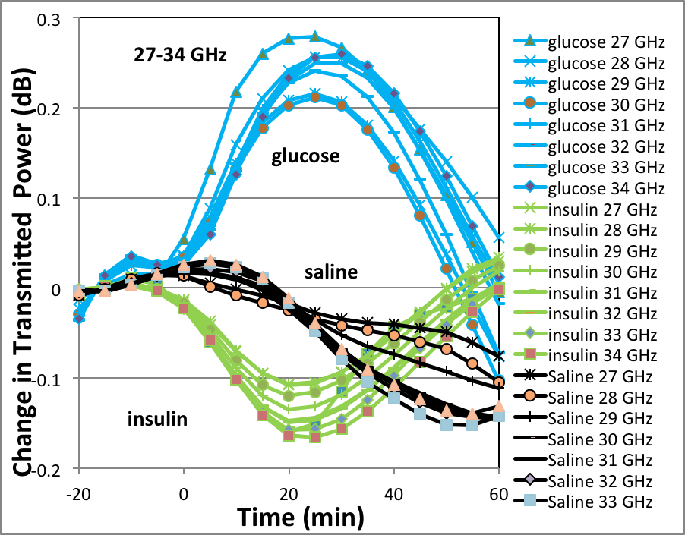

**Fig. 2.** Change in millimeter-wave transmission through the animal ear as a function of time for various frequencies between 27-34 GHz. At time t=0 injections were given of: 2g/kg Glucose (blue), 1 ml Saline (black) and 2 Units/kg Insulin (green). Typical absorption time is 20 minutes. Note that the levels track the expected shift in absorption due to change in the imaginary part of the index of refraction, consistent with prior data from published millimeter wave measurements on blood glucose (see text).

Add a summary if you have room. Add a summary if you have room. Add a summary if you have room. Add a summary if you have room. Add a summary if you have room.

References

[1]. References should be in IEEE standard transactions format as shown below. Use Author Initials followed by last name, then quotation marks around the full paper title, followed by journal name in italics, volume, pages, and date.

[2]. A.B. Lastname1, C.D. Lastname2 and E. Lastname3, “Title of the article,” *Journal Name in Italics,* vol. #, pp. 1-10, month, year.

[3]. C-F So, K-S Choi, T. KS Wong, and J. WY Chung, “Recent advances in noninvasive glucose monitoring,” *Medical Devices: Evidence and Research*, Dove Press, vol. 5, pp. 45-52, 2012.

[4]. E. Topsakai, T. Karacolak and E.C. Moreland, “Glucose dependent dielectric properties of blood plasma,” *XXXth URSI Symposium*, pp. 1-4, Istanbul, Turkey, Aug. 13-20, 2011.